User Story 2204913: PCP: Ignore product references to non-existing products.

Scenario: Verifying the reference product is not included in the denorm table when it’s not approved in the same context.

CTN: R2307_160223_01 | PRD-6995638 |

GVW completed [2 – “Has Accessory” Ref products are present]
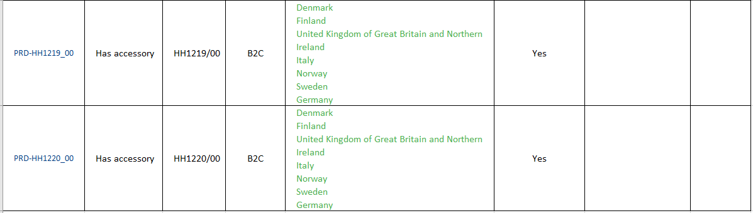

LVW completed.

PRD-6995638#en_US

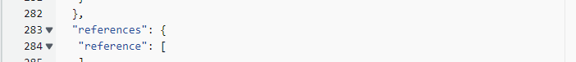

Starting LVW again.
Added one ref product.
Total products

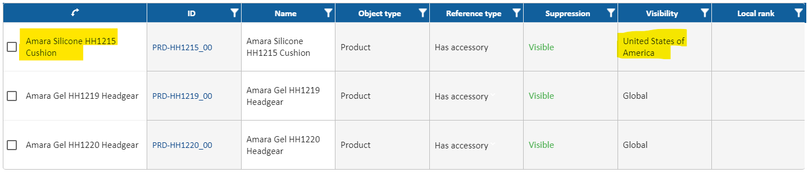

Completing LVW.

PRD-6995638#en_US

Then Navigate to Dynamo db and Verify whether the en_DK product is added as accessory for en_US product in denorm table
The referenced product should not be included --> PASS.
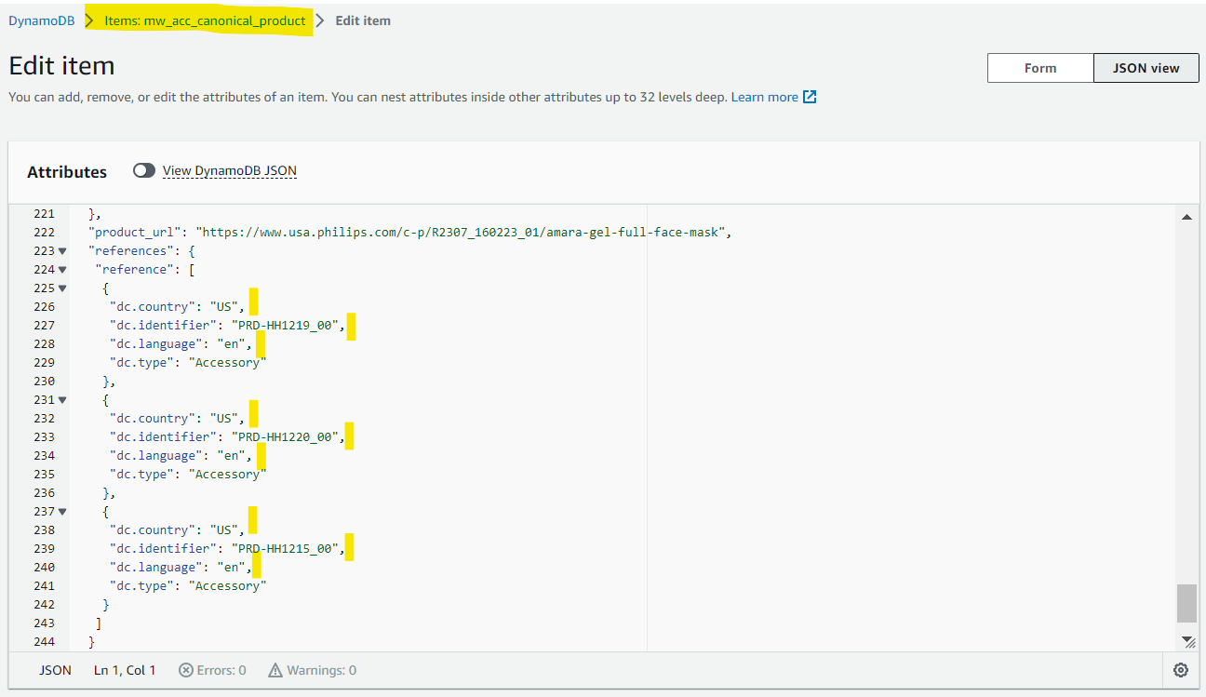

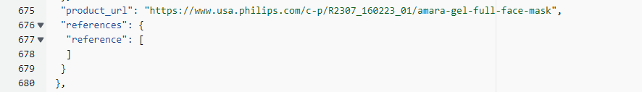

Approving the referenced product in en_US context.
PRD-HH1215_00
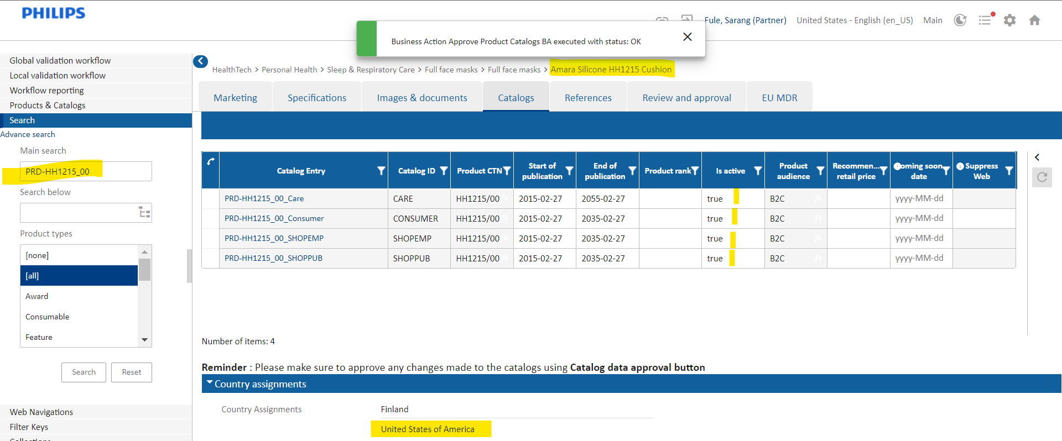

LVW not completed. Just approved the catalogs in en_US context.

Denorm table.
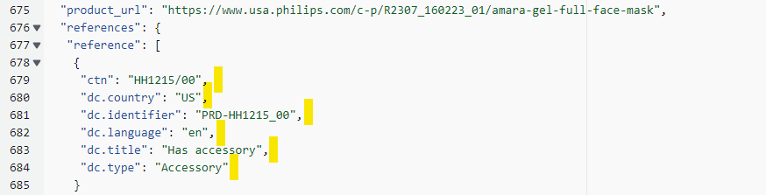

PASS

Scenario: Verifying the reference product is included in the denorm table when it is partially approved in same context

Master PRD: PRD-6995638

PRD-6996380 --> Created in step workbench.

GVW Completed.

Switched to en_DK context.
Saved catalogs with value as true.
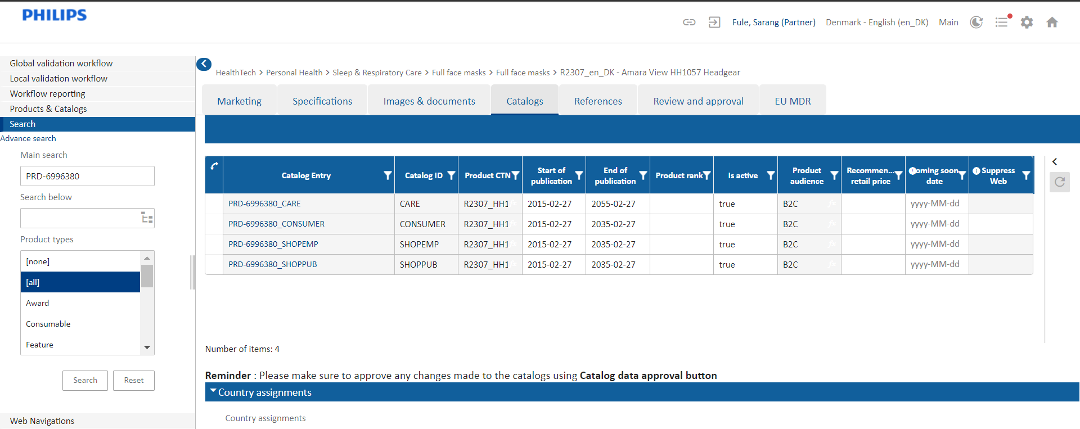

Adding en_Dk product reference in master product and completing LVW in local en_US context.
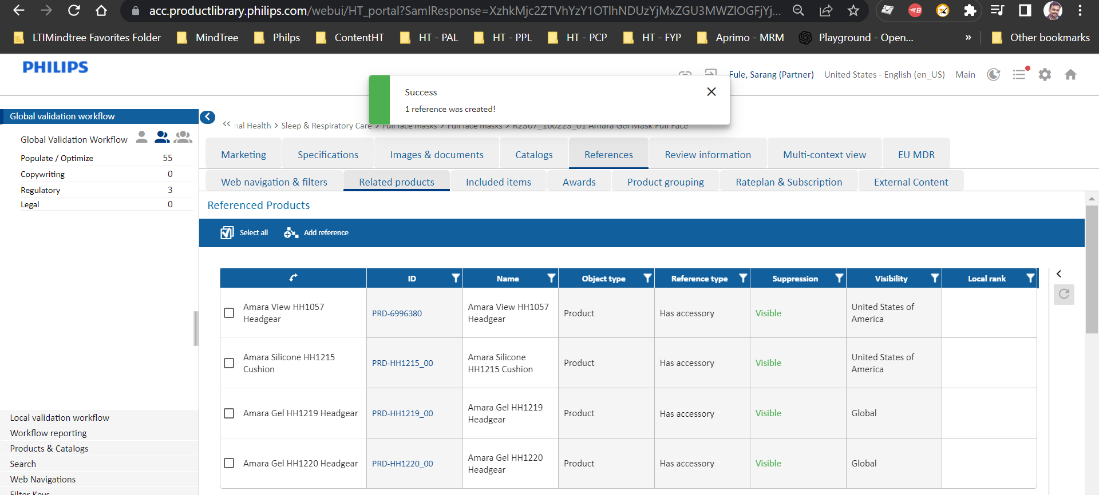

Completed LVW.
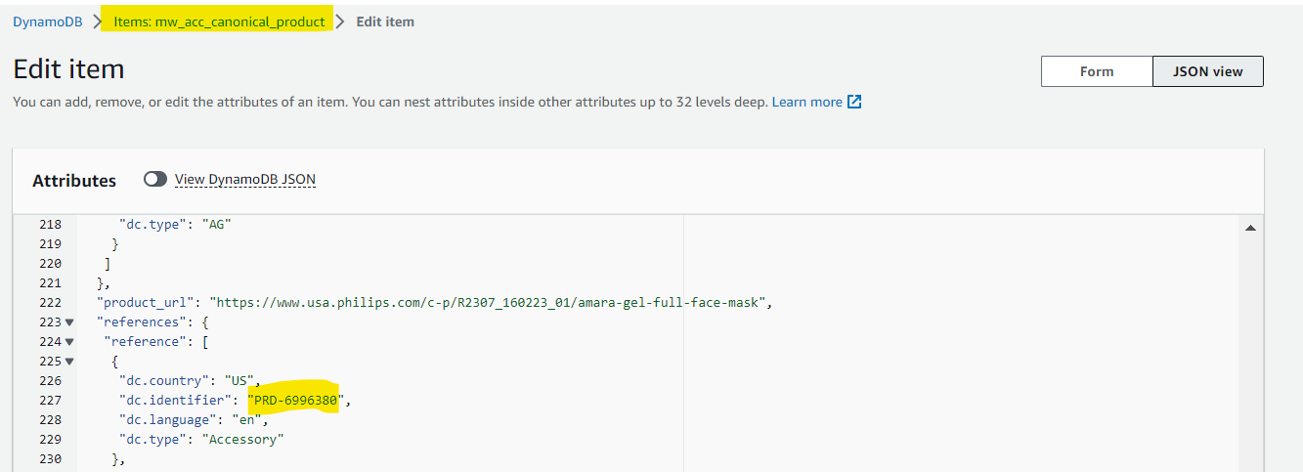

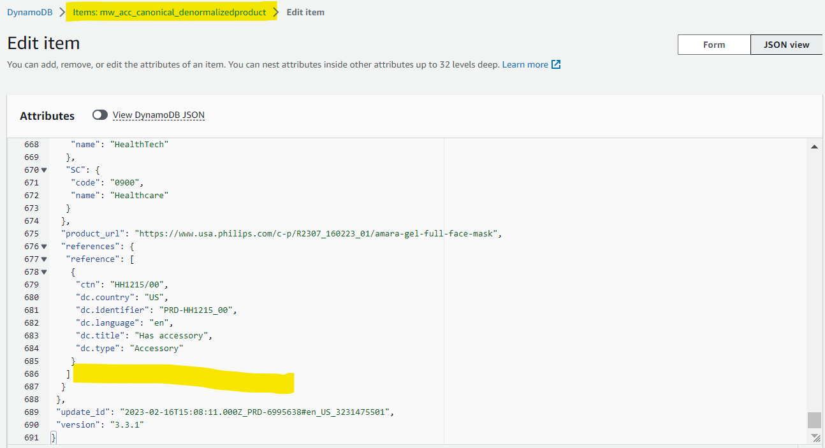

Approved product partially from step workbench.
Success message is shown for full as the partial approval was already done before. So modified the SC.
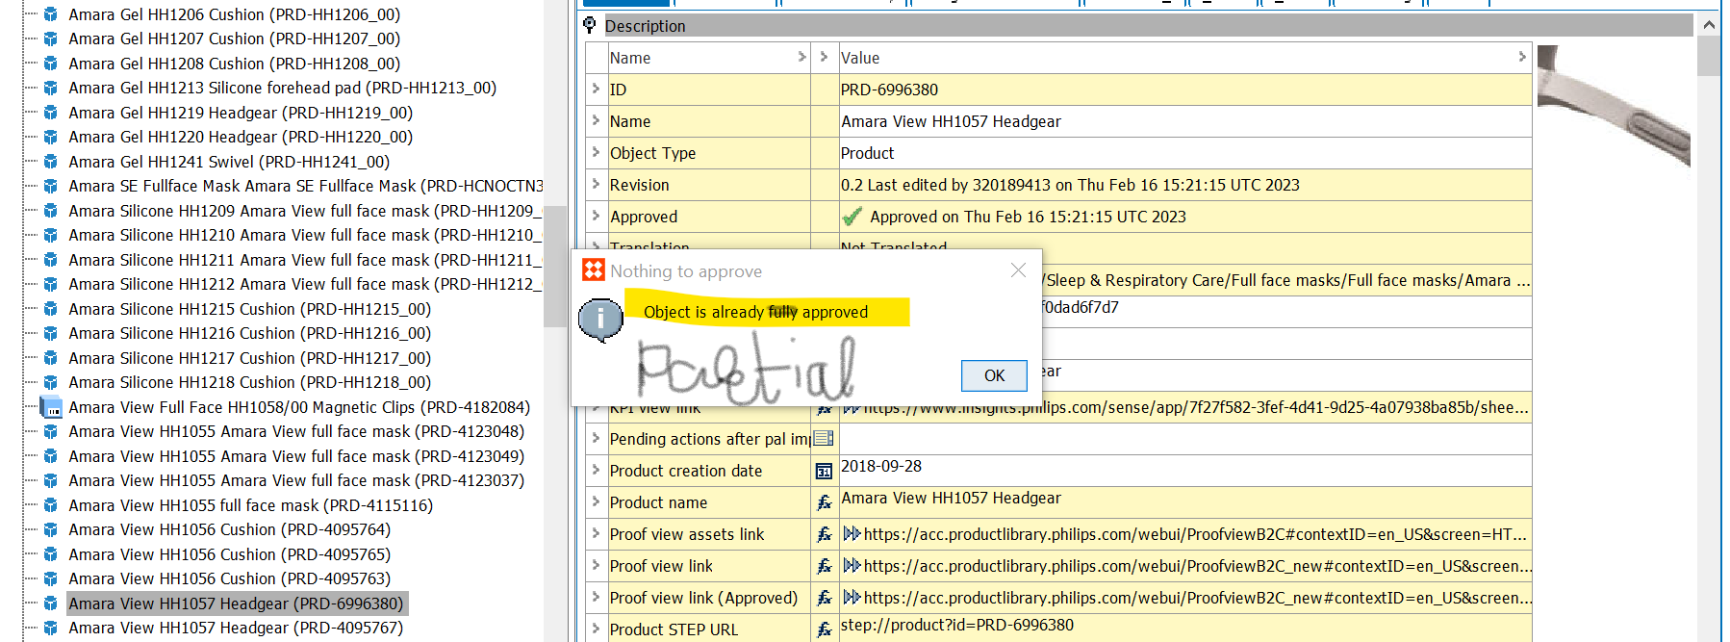

Checking the same in Denorm table.

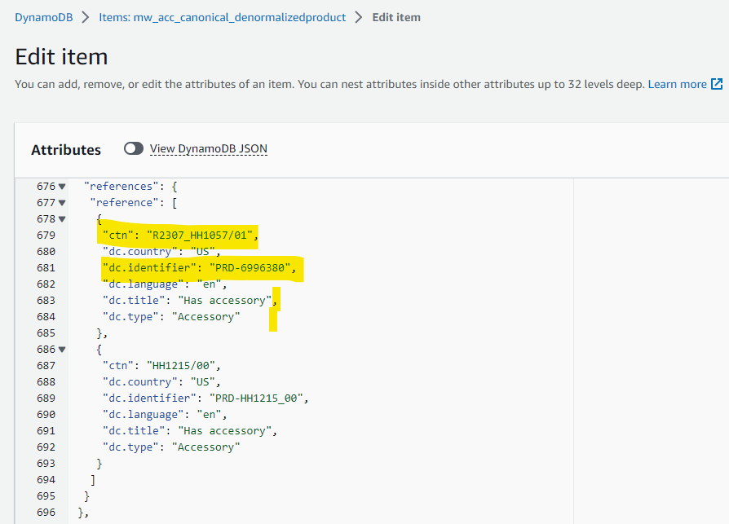

TC Passed.

