TC01-Verify that keyword in PAL is displayed in a correct format.
Open the Veeva URL :- https://sb-philips-promomats-qa.veevavault.com/
User should be navigated to the login page of VeevaVault. 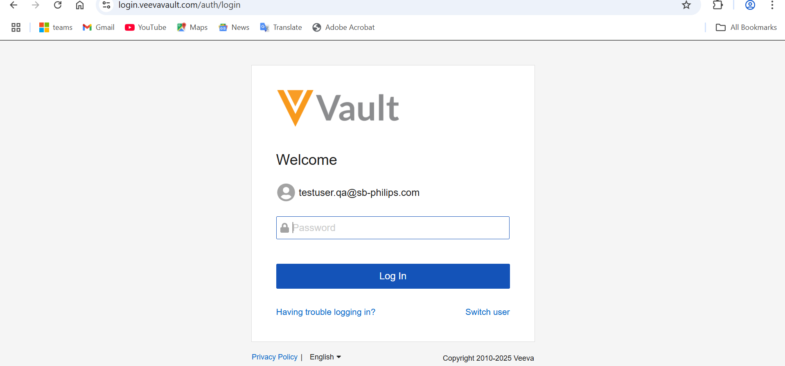
Enter valid username and password and click on Login button.
User should be able to enter the valid creds and navigated to Homepage/Dashboard up to clicking login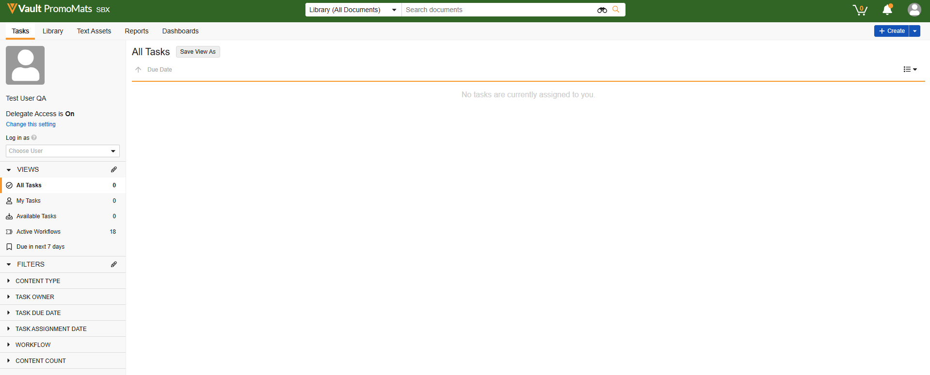
Click on Create button from top right corner and select Document, Either drag or upload a test file and select Document type as Material
The button should be clickable user should be navigated to create document page, The file should get uploaded and user should be able to select Document type as material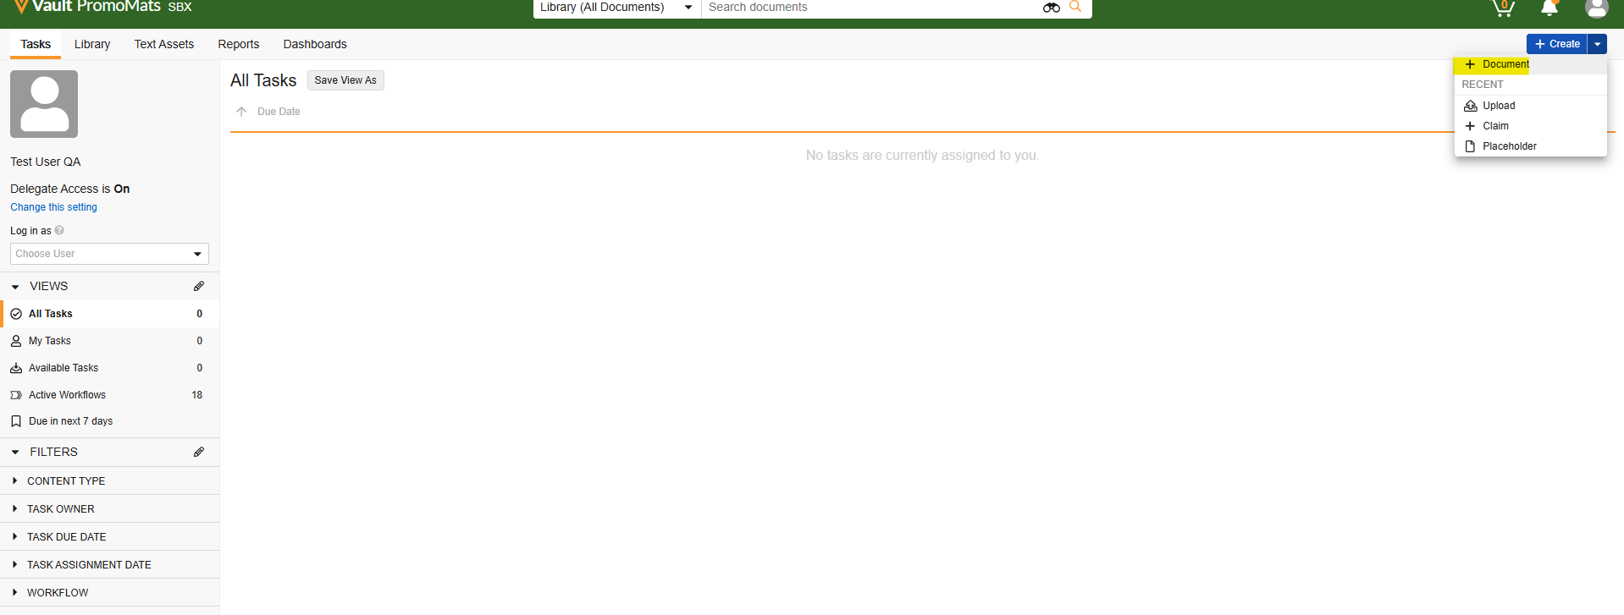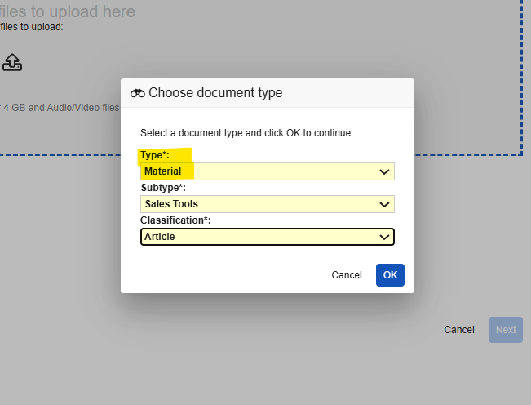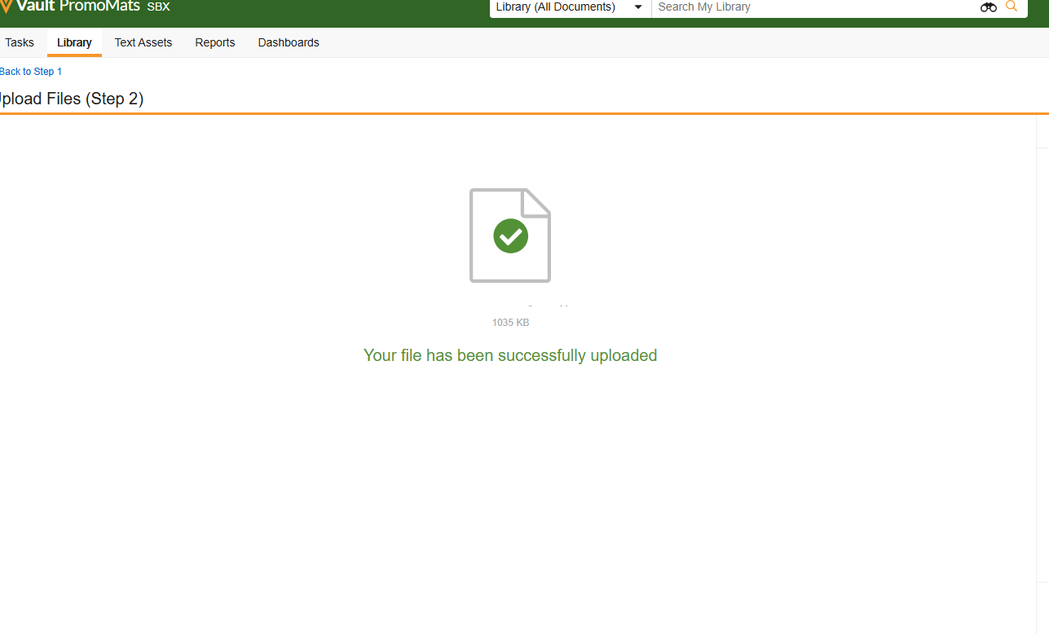
Now add data in all the mandatory fields. Add data in keyword field and set Sent to PAL to YES.
User should be able to add values in fields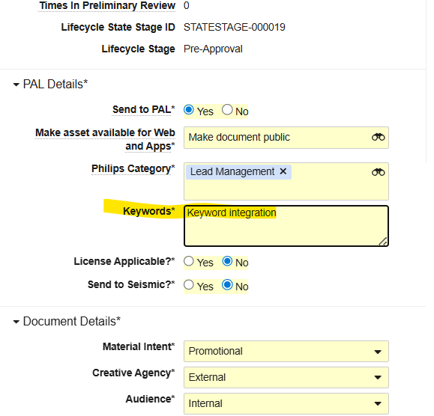
Complete the approval process till Approved for distribution
The document status should be Approved for Distribution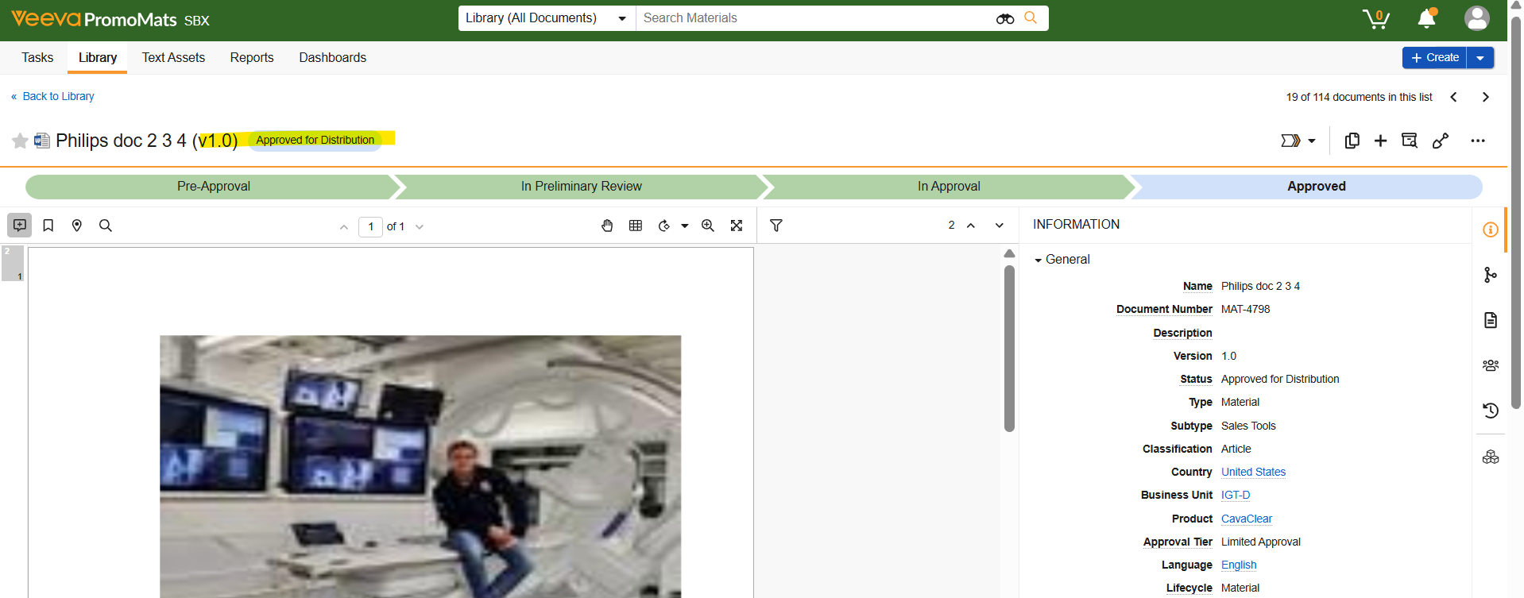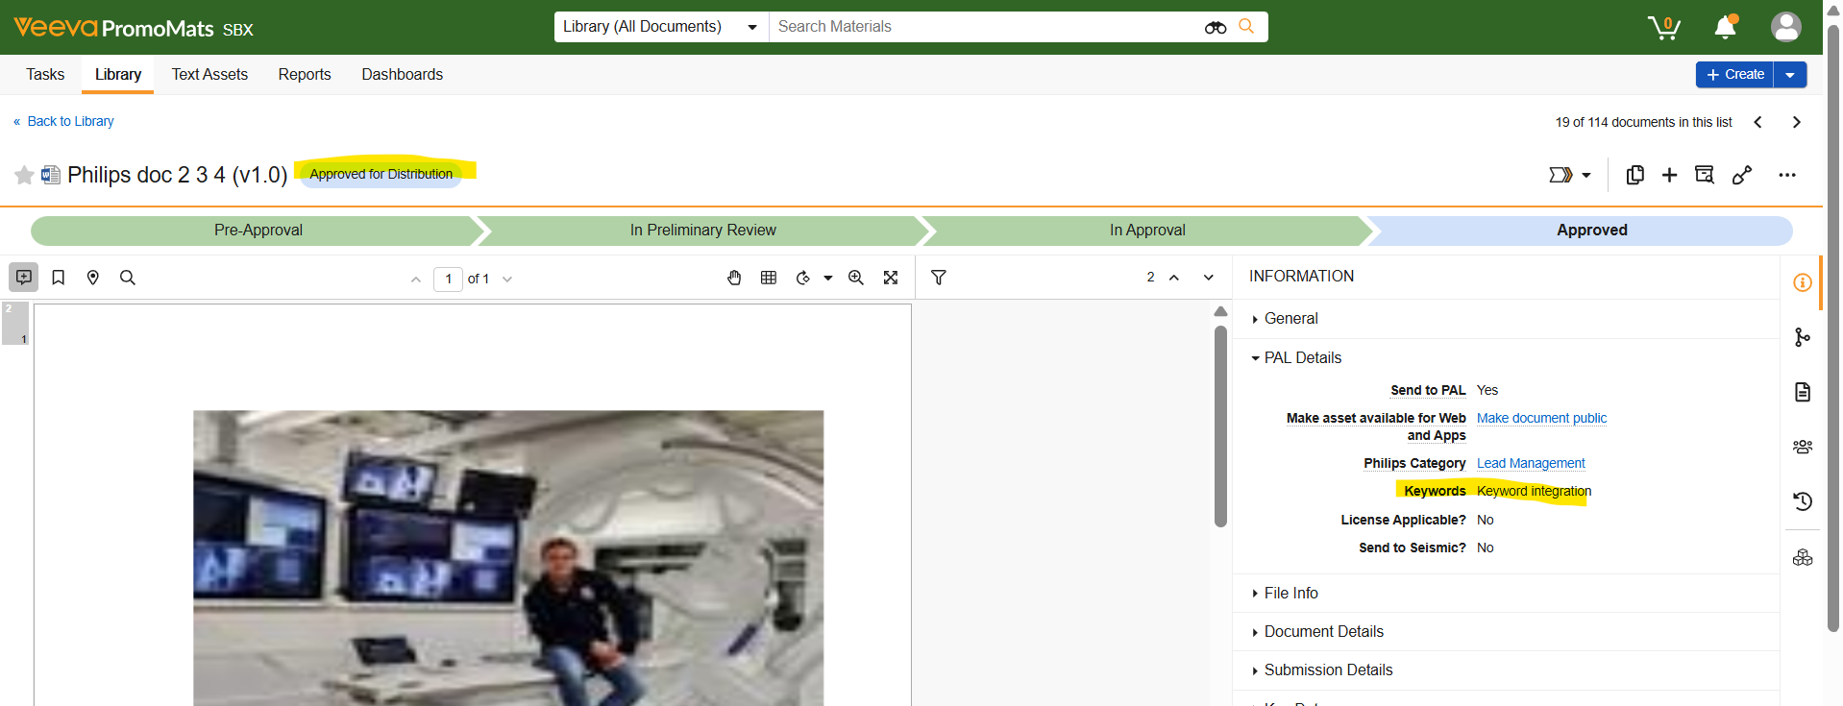

Take the document number and search in PAL
The document should get integrated with PAL