Accessing the IntelliVue Instructions for Use
English
The Instructions for Use for your IntelliVue monitor can be viewed and/or downloaded from the internet.

Download the Electronic Instructions for Use from the Internet
Product Information
The system serial number can be found on the serial number plate on your device or in your monitor software menu. To access the monitor revision screen:
- Enter the Main Setup menu and select Revision.
- Select Product.
- Select Software Revision.
- Select the pop-up key for the device you want to check (e.g. 866470). Note product and serial number that is displayed.
- Go to www.philips.com/ifu: 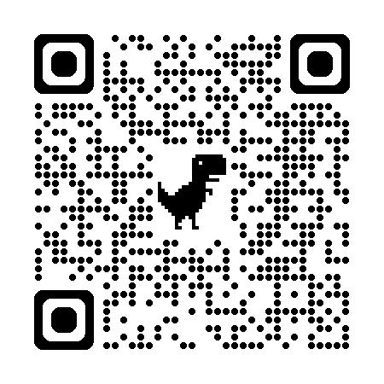
- Click on Link to find IFU by serial number & part number under the Product usage documents section.
- Enter the serial number and product number in the appropriate fields and click Find to open or download the document.

Request a Paper Copy of the Instructions for Use
- Find the 12-digit identification number (part number) of the document opened above (this is typically on the last page).
- Go to www.philips.com/ifu and follow the instructions on the webpage to request a paper copy.

 | ©Koninklijke Philips N.V., 2026  All rights are reserved  45366xxxxxxx  Revision A  2026-xx  Printed in the EU

In the European Union, you will receive a paper copy of the Instructions for Use within 7 Calendar days.

